NAME -Pranjal Pandey
SupersetID – 800655
Cognizant-Hands-on-Exercises

WEEK-2 : Spring Core And Maven

EXERCISE 1: Configuring a Basic Spring Application

Scenario:
Your company is developing a web application for managing a library. You need to use the Spring Framework to handle the backend operations.

Steps:
- Set Up a Spring Project:
  - Create a Maven project named LibraryManagement.
  - Add Spring Core dependencies in the pom.xml file.
- Configure the Application Context:
  - Create an XML configuration file named applicationContext.xml in the src/main/resources directory.
  - Define beans for BookService and BookRepository in the XML file.
- Define Service and Repository Classes:
  - Create a package com.library.service and add a class BookService.
  - Create a package com.library.repository and add a class BookRepository.
- Run the Application:
  - Create a main class to load the Spring context and test the configuration.

Solution Code:
BookService.java
package com.library.service;
import com.library.repository.BookRepository; public class BookService {

private BookRepository bookRepository;

public void setBookRepository(BookRepository bookRepository) { this.bookRepository = bookRepository;
}

public void getBooks() { System.out.println("Book Service Called"); bookRepository.displayBooks();
}
}
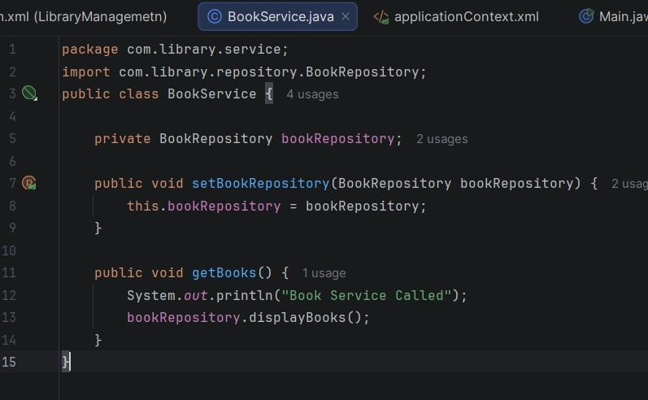

BookRepository.java
package com.library.repository; public class BookRepository {
public void displayBooks() {
System.out.println("Fetching books from repository...");
}
}
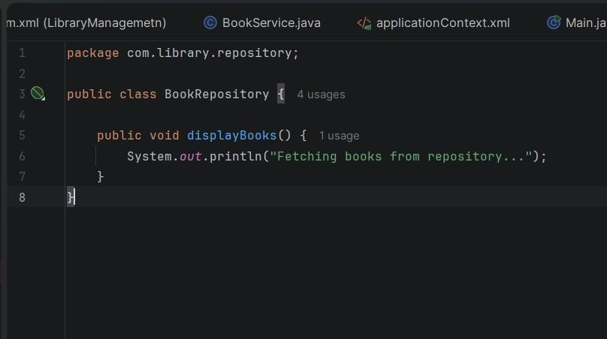

Main.java
import com.library.service.BookService;
import org.springframework.context.ApplicationContext;
import org.springframework.context.support.ClassPathXmlApplicationContext; public class Main {
public static void main(String[] args) {
ApplicationContext context = new ClassPathXmlApplicationContext("applicationContext.xml"); BookService bookService = context.getBean("bookService", BookService.class);
bookService.getBooks();
}
}

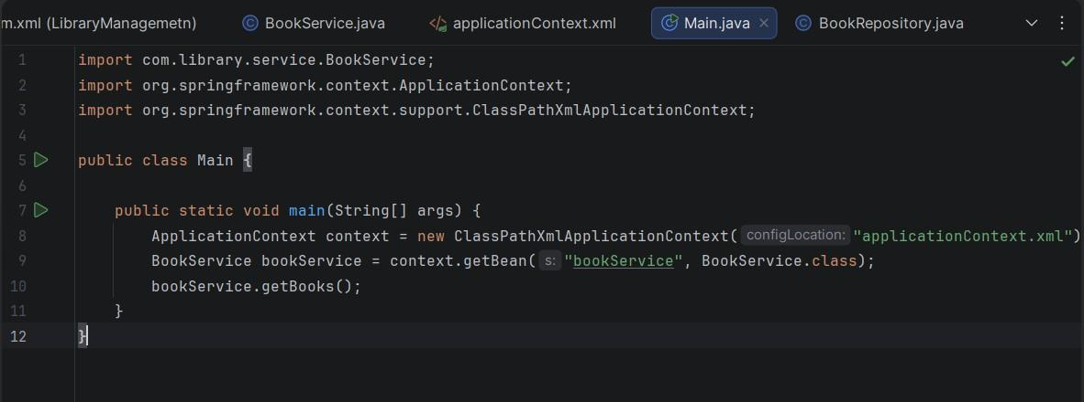

applicationContext.xml
<?xml version="1.0" encoding="UTF-8"?>

<beans xmlns="http://www.springframework.org/schema/beans" xmlns:xsi="http://www.w3.org/2001/XMLSchema-instance" xsi:schemaLocation=" http://www.springframework.org/schema/beans https://www.springframework.org/schema/beans/spring-beans.xsd">

<bean id="bookRepository" class="com.library.repository.BookRepository"/>

<bean id="bookService" class="com.library.service.BookService">

<property name="bookRepository" ref="bookRepository"/></bean></beans>

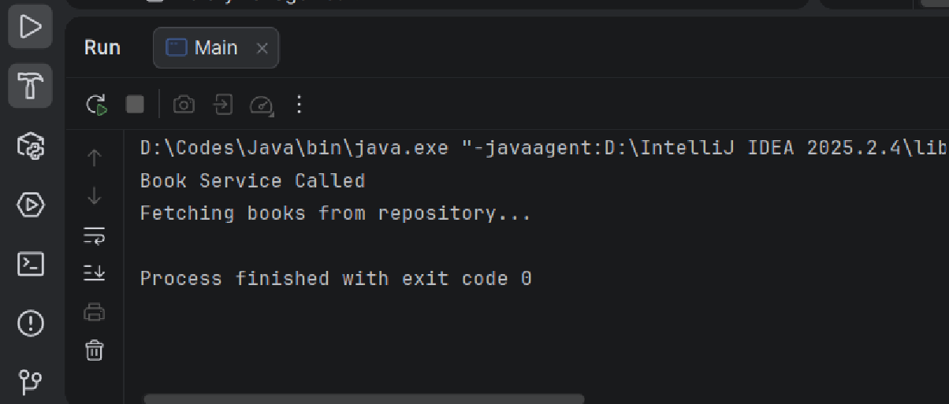
OUTPUT:

EXERCISE 2 : Implementing Dependency Injection

Scenario:
In the library management application, you need to manage the dependencies between the BookService and BookRepository classes using Spring's IoC and DI.

Steps:
- Modify the XML Configuration:
  - Update applicationContext.xml to wire BookRepository into BookService.
- Update the BookService Class:
  - Ensure that BookService class has a setter method for BookRepository.
- Test the Configuration:
  - Run the LibraryManagementApplication main class to verify the dependency injection.

Solution Code:
BookService.java
package com.library.service;
import com.library.repository.BookRepository; public class BookService {

private BookRepository bookRepository;

public void setBookRepository(BookRepository bookRepository) { this.bookRepository = bookRepository;
}

public void getBooks() { System.out.println("Book Service Called"); bookRepository.displayBooks();
}
}


BookRepository.java
package com.library.repository; public class BookRepository {
public void displayBooks() {
System.out.println("Fetching books from repository...");
}
}


Main.java
import com.library.service.BookService;
import org.springframework.context.ApplicationContext;
import org.springframework.context.support.ClassPathXmlApplicationContext; public class Main {
public static void main(String[] args) {
ApplicationContext context = new ClassPathXmlApplicationContext("applicationContext.xml"); BookService bookService = context.getBean("bookService", BookService.class);
bookService.getBooks();
}
}



applicationContext.xml
<?xml version="1.0" encoding="UTF-8"?>

<beans xmlns="http://www.springframework.org/schema/beans" xmlns:xsi="http://www.w3.org/2001/XMLSchema-instance" xsi:schemaLocation=" http://www.springframework.org/schema/beans https://www.springframework.org/schema/beans/spring-beans.xsd">

<bean id="bookRepository" class="com.library.repository.BookRepository"/>

<bean id="bookService" class="com.library.service.BookService">

<property name="bookRepository" ref="bookRepository"/></bean></beans>

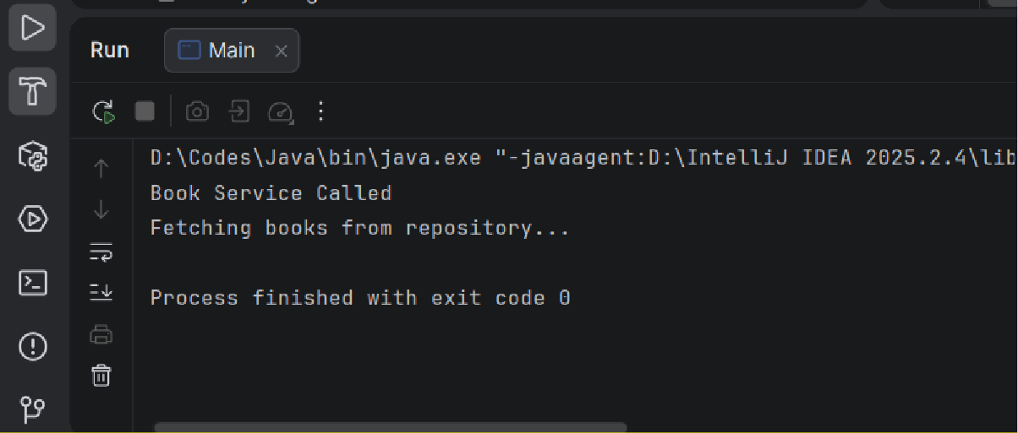
OUTPUT:

EXERCISE 4: Creating and Configuring a Maven Project

Scenario:
You need to set up a new Maven project for the library management application and add Spring dependencies.

Steps:
- Create a New Maven Project:
  - Create a new Maven project named LibraryManagement.
- Add Spring Dependencies in pom.xml:
  - Include dependencies for Spring Context, Spring AOP, and Spring WebMVC.
- Configure Maven Plugins:
  - Configure the Maven Compiler Plugin for Java version 1.8 in the pom.xml file.

Solution Code:
Pom.xml
<?xml version="1.0" encoding="UTF-8"?>
<project xmlns="http://maven.apache.org/POM/4.0.0" xmlns:xsi="http://www.w3.org/2001/XMLSchema-instance" xsi:schemaLocation="http://maven.apache.org/POM/4.0.0
http://maven.apache.org/xsd/maven-4.0.0.xsd">
<modelVersion>4.0.0</modelVersion>

<groupId>org.solutions.cognizant</groupId>
<artifactId>LibraryManagemetn</artifactId>
<version>1.0-SNAPSHOT</version>

<properties>
<maven.compiler.source>24</maven.compiler.source>
<maven.compiler.target>24</maven.compiler.target>
<project.build.sourceEncoding>UTF-8</project.build.sourceEncoding>
</properties>

<dependencies>
<dependency>
<groupId>org.springframework</groupId>
<artifactId>spring-context</artifactId>
<version>5.3.39</version>
</dependency>

<dependency>
<groupId>org.springframework</groupId>
<artifactId>spring-context</artifactId>
<version>5.3.39</version>
</dependency>

<dependency>
<groupId>org.springframework</groupId>
<artifactId>spring-aop</artifactId>
<version>5.3.39</version>
</dependency>

<dependency>
<groupId>org.springframework</groupId>
<artifactId>spring-webmvc</artifactId>
<version>5.3.39</version>
</dependency>

</dependencies>

<build>
<plugins>

<plugin>
<groupId>org.apache.maven.plugins</groupId>
<artifactId>maven-compiler-plugin</artifactId>
<version>3.11.0</version>
<configuration>
<source>1.8</source>
<target>1.8</target>
</configuration>
</plugin>

</plugins>
</build>

</project>
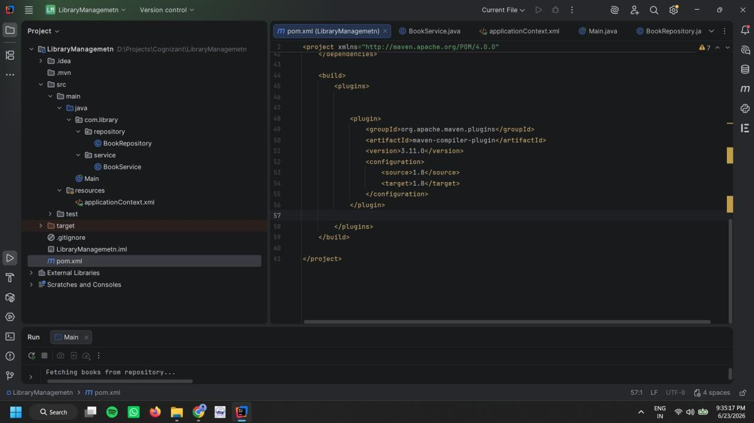

Output:

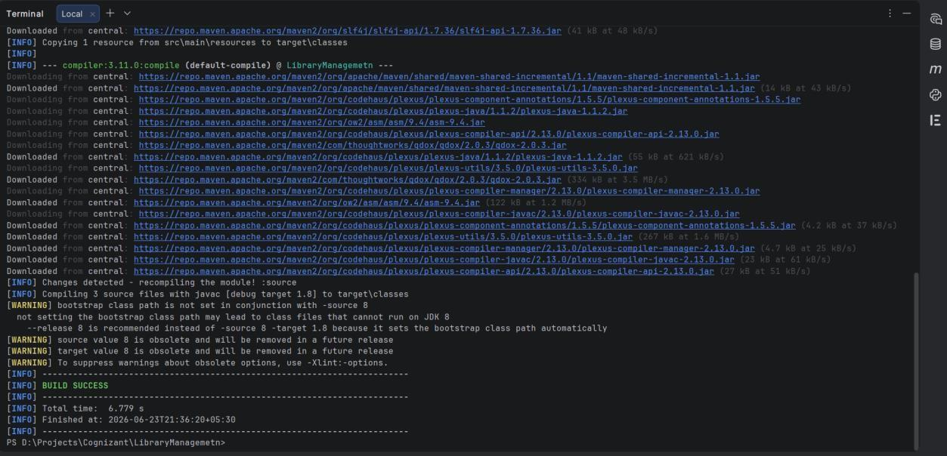

EXERCISE 5: Configuring the Spring IoC Container

Scenario:
The library management application requires a central configuration for beans and dependencies.

Steps:
- Create Spring Configuration File:
  - Create an XML configuration file named applicationContext.xml in the src/main/resources directory.
  - Define beans for BookService and BookRepository in the XML file.
- Update the BookService Class:
  - Ensure that the BookService class has a setter method for BookRepository.
- Run the Application:
  - Create a main class to load the Spring context and test the configuration.

Solution Code:
BookService.java
package com.library.service;
import com.library.repository.BookRepository; public class BookService {
private BookRepository bookRepository;

public void setBookRepository(BookRepository bookRepository) { this.bookRepository = bookRepository;
}

public void getBooks() { System.out.println("Book Service Called"); bookRepository.displayBooks();
}
}


BookRepository.java
package com.library.repository; public class BookRepository {

public void displayBooks() {
System.out.println("Fetching books from repository...");
}
}


applicationContext.xml

<?xml version="1.0" encoding="UTF-8"?>

<beans xmlns="http://www.springframework.org/schema/beans" xmlns:xsi="http://www.w3.org/2001/XMLSchema-instance" xsi:schemaLocation=" http://www.springframework.org/schema/beans https://www.springframework.org/schema/beans/spring-beans.xsd">

<bean id="bookRepository" class="com.library.repository.BookRepository"/>

<bean id="bookService" class="com.library.service.BookService">

<property name="bookRepository" ref="bookRepository"/>

</bean>

</beans>
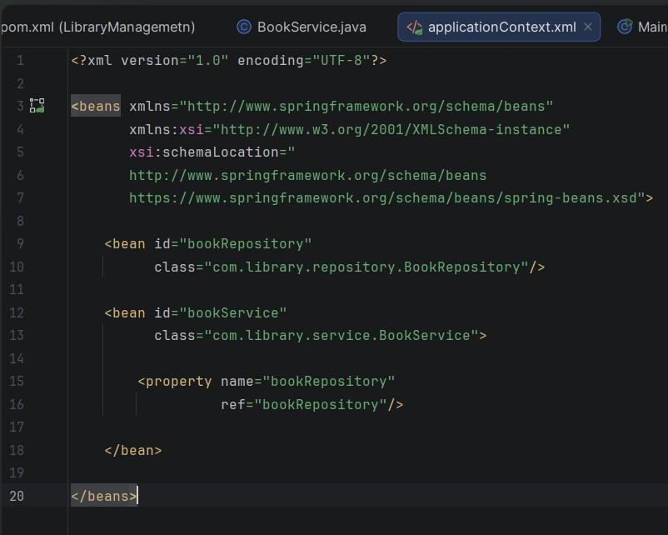

Main.java
import com.library.service.BookService;
import org.springframework.context.ApplicationContext;
import org.springframework.context.support.ClassPathXmlApplicationContext; public class Main {
public static void main(String[] args) { ApplicationContext context = new
ClassPathXmlApplicationContext("applicationContext.xml");
BookService bookService = context.getBean("bookService", BookService.class); bookService.getBooks();
}
}
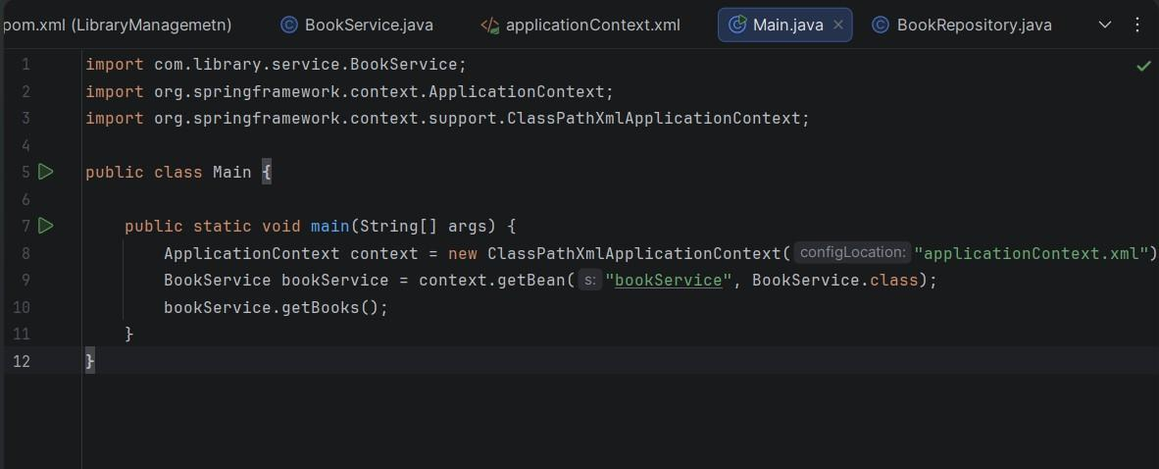

EXERCISE 7: Implementing Constructor and Setter Injection

Scenario:
The library management application requires both constructor and setter injection for better control over bean initialization.

Steps:
- Configure Constructor Injection:
  - Update applicationContext.xml to configure constructor injection for BookService.
- Configure Setter Injection:
  - Ensure that the BookService class has a setter method for BookRepository and configure it in applicationContext.xml.
- Test the Injection:
Run the LibraryManagementApplication main class to verify both constructor and setter injection.

Solution Code:
applicationContext.xml
<?xml version="1.0" encoding="UTF-8"?>
<beans xmlns="http://www.springframework.org/schema/beans" xmlns:xsi="http://www.w3.org/2001/XMLSchema-instance" xsi:schemaLocation=" http://www.springframework.org/schema/beans https://www.springframework.org/schema/beans/spring-beans.xsd">
<bean id="bookRepository" class="com.library.repository.BookRepository"/>
<bean id="bookService" class="com.library.service.BookService">
<constructor-arg value="Central Library"/>
<property name="bookRepository" ref="bookRepository"/>
</bean>
</beans>
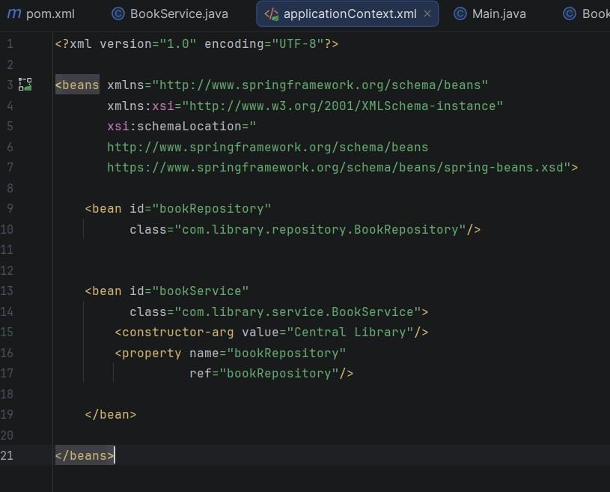

BookService.java
package com.library.service;
import com.library.repository.BookRepository; public class BookService {

private String bookName;
private BookRepository bookRepository;
public BookService(String bookName) { this.bookName = bookName;
}

public void setBookRepository(BookRepository bookRepository) { this.bookRepository = bookRepository;
}

public void getBooks() {
System.out.println("Book Service Called: "+bookName); bookRepository.displayBooks();
}
}
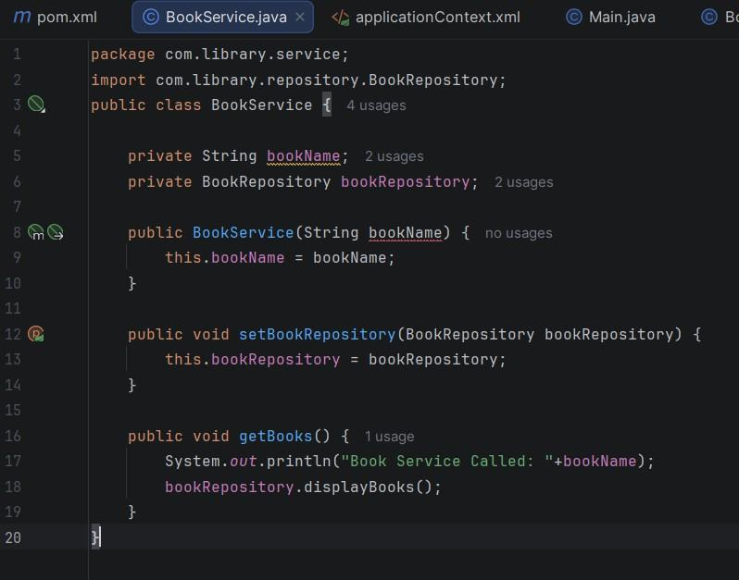

OUTPUT :
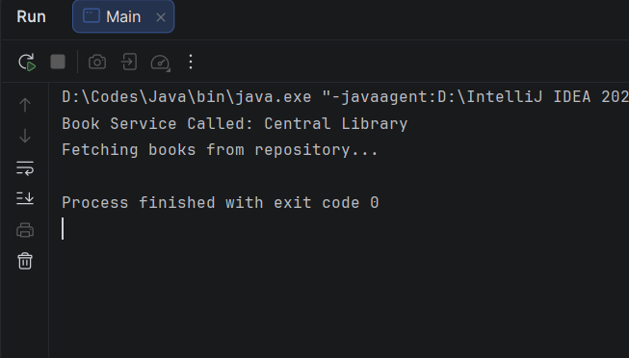

Exercise 9: Creating a Spring Boot Application

Scenario:
You need to create a Spring Boot application for the library management system to simplify configuration and deployment.

Steps:
- Create a Spring Boot Project:
  - Use Spring Initializr to create a new Spring Boot project named
LibraryManagement.
- Add Dependencies:
  - Include dependencies for Spring Web, Spring Data JPA, and H2 Database.
- Create Application Properties:
  - Configure database connection properties in application.properties.
- Define Entities and Repositories:
  - Create Book entity and BookRepository interface.
- Create a REST Controller:
  - Create a BookController class to handle CRUD operations.
- Run the Application:
  - Run the Spring Boot application and test the REST endpoints.
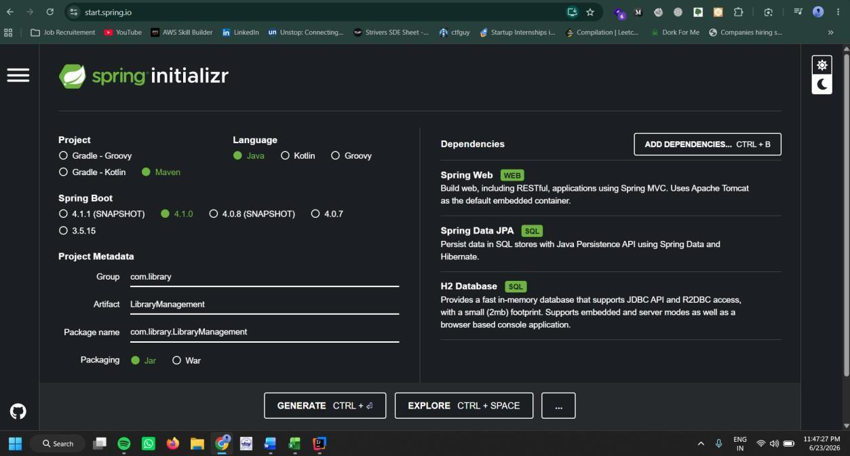

Application.properlties

spring.datasource.url=jdbc:h2:mem:librarydb spring.datasource.driverClassName=org.h2.Driver spring.datasource.username=sa spring.datasource.password= spring.jpa.hibernate.ddl-auto=update spring.jpa.show-sql=true spring.h2.console.enabled=true spring.h2.console.path=/h2-console
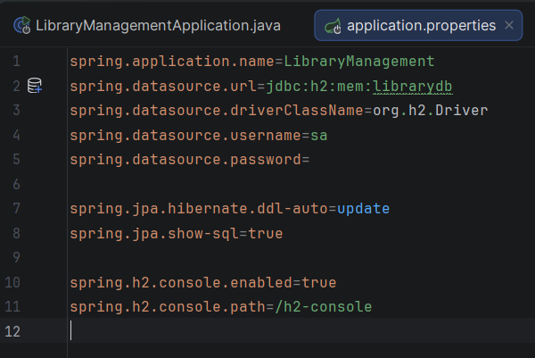

Book.java
package com.library.entity;

import jakarta.persistence.Entity;
import jakarta.persistence.GeneratedValue; import jakarta.persistence.GenerationType; import jakarta.persistence.Id;

@Entity
public class Book {

@Id
@GeneratedValue(strategy = GenerationType.IDENTITY) private Long id;

private String title; private String author;

public Book() {
}

public Book(Long id, String title, String author) { this.id = id;
this.title = title; this.author = author;
}

public Long getId() { return id;
}

public void setId(Long id) { this.id = id;
}

public String getTitle() { return title;
}

public void setTitle(String title) { this.title = title;
}

public String getAuthor() { return author;
}

public void setAuthor(String author) { this.author = author;
}}
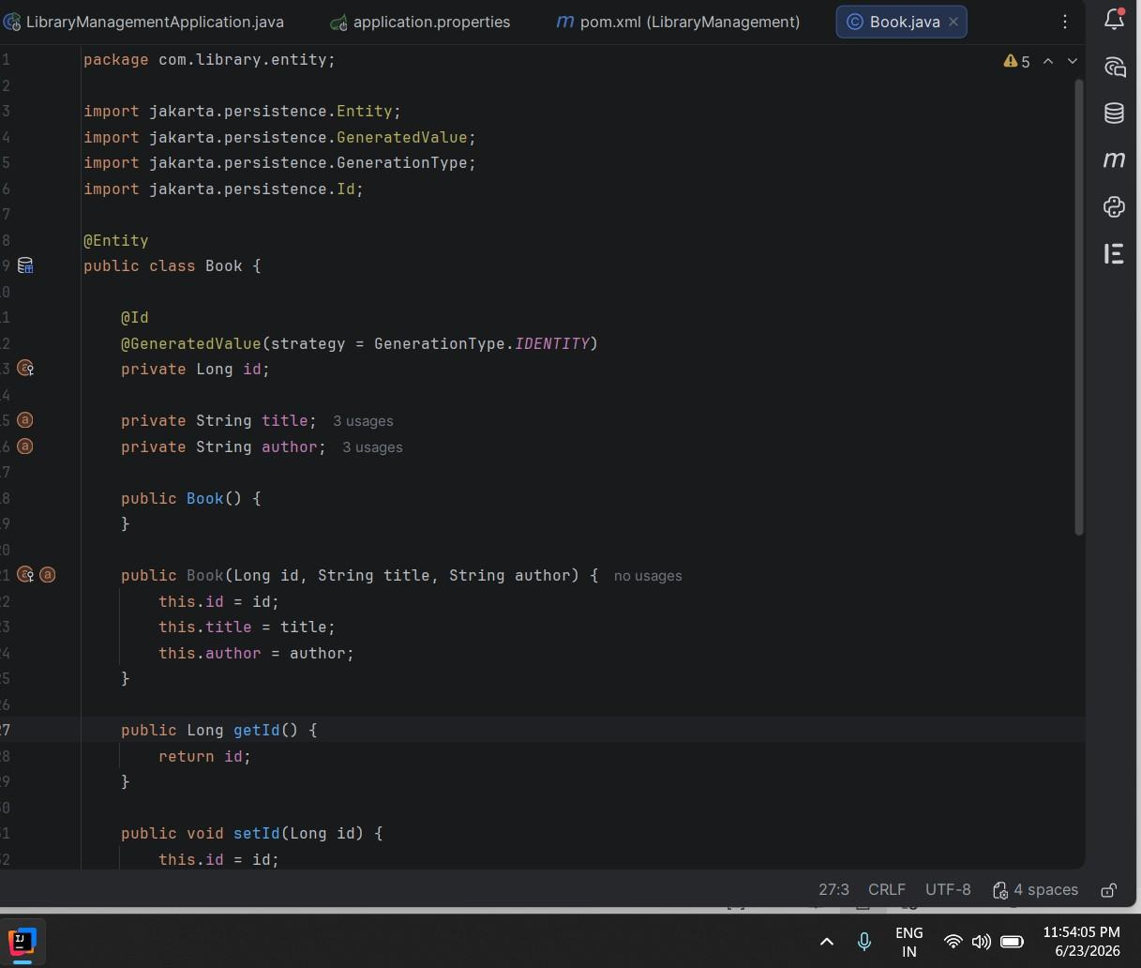

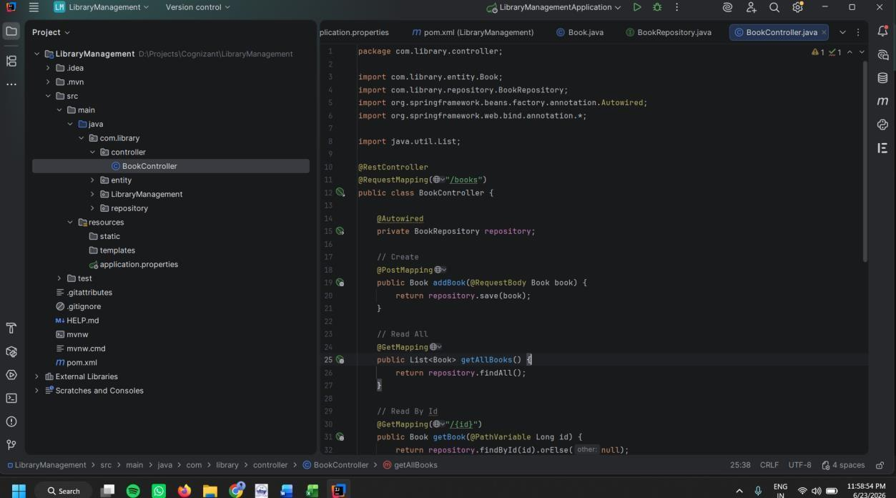

LibraryManagement.java:
package com.library;

import org.springframework.boot.SpringApplication;
import org.springframework.boot.autoconfigure.SpringBootApplication;

@SpringBootApplication
public class LibraryManagementApplication {

public static void main(String[] args) { SpringApplication.run(LibraryManagementApplication.class, args);
}

}
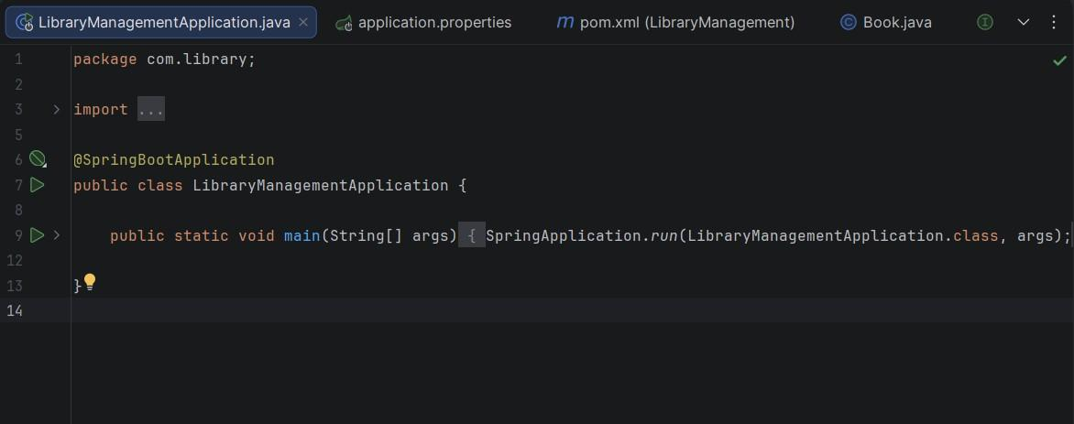

Output:
